The Savior Meme
The late Stanford philosopher and therapist Paul Watzlawick had a good way of explaining how to get out of impossible jams. When change is required, there are different ways to think about the level of creativity that’s needed.
A “first-order” change is to stamp on the gas pedal. A second- order change is to shift gears. A third-order change is to get out of the car and find another way to get there.
That’s where we are now.
Here’s a radical new way to think about it all.
If you burrow deep into the innards of the capitalist system, you discover a glaring flaw. The vast majority of our carbon emissions are unpriced. We buy a car for $35,000, then drive it around for ten years creating thousand dollars’ worth of global warming. Who pays for that damage? Do future generations have to clean up our mess? The illogic extends from the gas we pump into our cars to the smart phones we carry in our pockets to the Big Macs we wolf down at McDonald’s. Out of the billions and billions of transactions made every day in our global marketplace, only a tiny fraction reflect their true cost. And each one drives us a little closer to global system collapse. With every bogus transaction, another drop of meltwater slides off an iceberg, another puff of CO2 rises to the sky, another bubble of methane wafts up from the tundra. If we keep repeating that mistake, billions of times a day, week after week, month after month, year after year, what do you think will happen?
To date, only a handful of economists have bothered to think about the true cost of what we buy and do. They speak the language of efficiency and have taught the whole world to do the same. So why are so many of our leading economists silent, then, on these, the greatest inefficiencies of all? Why are our markets not telling the truth? Why are we selling off our natural capital and calling it income? Why is the profession of economics committing such a monumental system error?
Let’s figure this out. What is the real cost of shipping a container load of toys from Chongqing to Los Angeles? Or a case of apples grown in New Zealand to markets in North America? And what is the true cost of that fridge humming 24/7 in your kitchen . . . that steak sizzling on your grill . . . that car sitting in your garage? What are the by-products of our way of living actually costing us? Grab a calculator and let’s get at this. Instead of watching economists pontificate endlessly about interest rates, stock-market swings and GDP growth, let’s put them to productive big-picture use crunching the real cost of things.

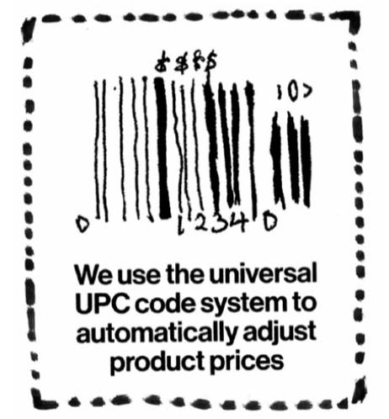
The Universal Product Code (UPC) is the perfect mechanism for implementing True Cost. Almost every product sold around the world already has a UPC code on it. It was originally created to speed up the checkout process and track inventory at grocery stores. Now it becomes an essential part of the True Cost project. The human experience of buying something is transformed. When you swipe it, a True Cost price adjustment automatically kicks in. All the costs of making and marketing and shipping and distributing the product you’re buying are baked into the price. One swipe, one truth. Sticker shock: take it or leave it.
— from Manifest For World Revolution

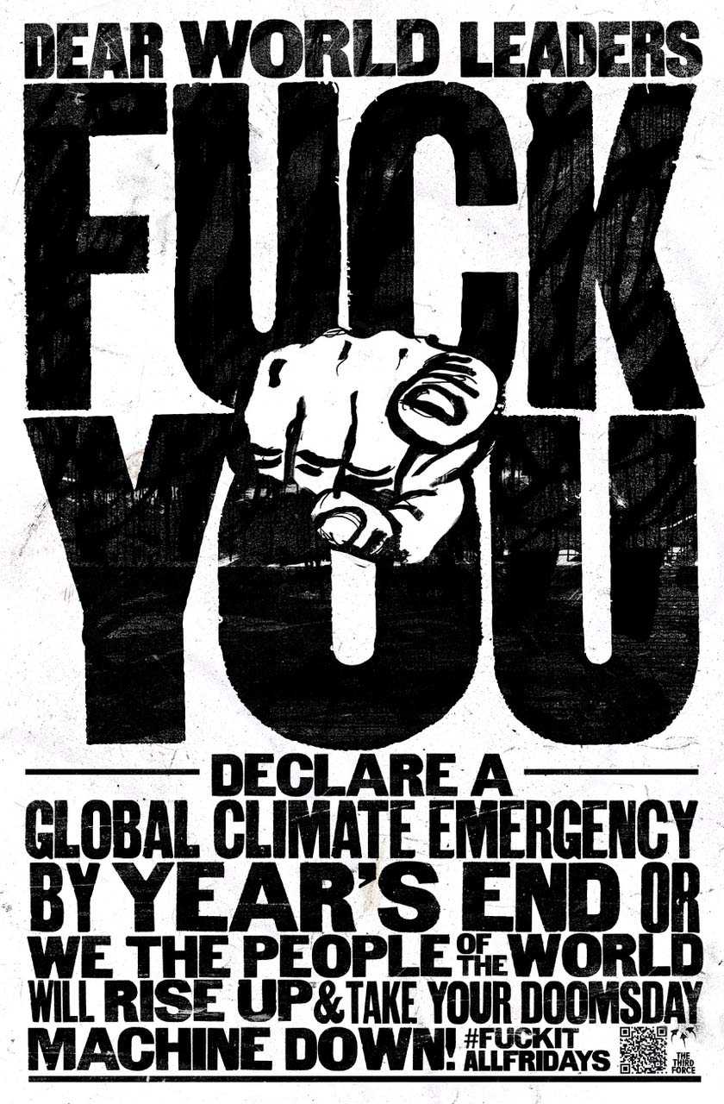

The Third Force

